Likes - Concerns - Wishes Process
Thursday, March 1, 2018 at 9:58AM “Means of Grace, Hope of Glory”

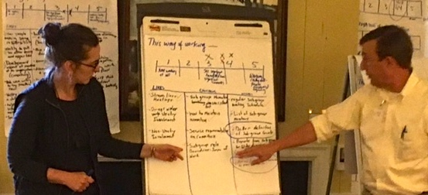

To assess, talk, and prioritize

This is a group method that provides structure to what can be a chaotic and time consuming piece of work.
For example:
The parish treasurer has given a financial report. We all know what follows next. People are either silent or the one or two money nerds start asking questions no one else has any interest in. Or worst yet, a vestry member unhappy with the rector uses this as an opportunity to attack, maybe bluntly, maybe with an attempt to appear reasonable while undercutting the rector's priorities.
We can do better. First, let's begin with the assumption that the financial report is only offered 3 or 4 times per year. And also, let's assume the report isn't given a routine placement on the agenda, i.e., always after the minutes. The design of any vestry meeting needs to pay attention to the group's energy and generally place the most important items early.
So, the treasurer has made the report. And those designing this particular meeting have decided they'd like to generate a thoughtful conversation around the report. (Note - there's no need to use the method every time. On occasion the standard, "Any questions or comments?" is adequate; at other times you may want to use another structured process.)
Have a spectrum or two written on newsprint (easel pads) in front of the group. The spectrum would include a range of responses -- "Parish finances seem in great shape" to "This is generally encouraging but I have a few concerns" to "Sounds like our financial situation is a disaster."
Responding to a spectrum such as this helps members stop and think about what they have heard. Especially if they have been told in advance that they will be asked to respond to the report in this manner.
"Likes - Concerns - Wishes" is written on three separate sheets of newsprint (can all be on one if space doesn't permit three sheets). The group brainstorms their ideas for each category and then prioritizes. The group discusses the top items.

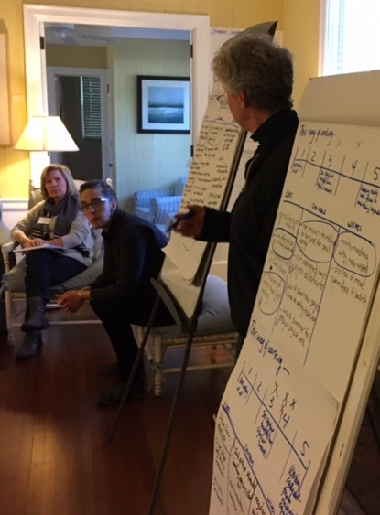

How the process works

Here's more detail on the process:
1. Have the process in front of the group on easel pads and in their hands as a worksheet (see below for sample worksheets).
The outline is -
A spectrum - 1 to 6 (or other) and descriptions at least at the two ends, e.g., "Very Low" .. "Very High" or other descriptions.
Three categories: Likes - Concerns - Wishes -- best on three separate sheets of newsprint but can be done on one page.
2. Have people come forward and place a mark on the spectrum
This gives the group a broad sense of its response. It may also shape the work and conversation that follows. If the response was all "6" there may not be much to say or the group may want to focus on "Likes" to see what elements are most significant in gaining such a high rating. If a few "concerns" are listed the group will be able to keep those concerns in perspective because it knows that the overall satisfaction rate is high.
Having them come forward tends to increase the group's energy. Even small amounts of movement can be useful.
3. Brainstorm in each category. The method that allows for a sense of both order and adaptability is to start with "Likes" but to allow people to break out of that category if what comes to mind is something in another category. Once that is recorded the facilitator can bring the group back to "Likes."
Remind the group of the norms for brainstorming:
- Offer whatever idea comes to mind. We want as many ideas as possible. We want ideas that seem obvious, and we want ideas that may seem “far out”.
- No discussion or evaluation of anyone’s ideas as we are gathering them. Keep the ideas coming in a stream. We want to keep the team’s energy up and focused on producing as many ideas as possible.
Use as many sheets of newsprint as needed. It will help the flow if several sheets are hung across the wall at the beginning. That will avoid an interruption because of the need to hang more newsprint. It may be useful to set a time limit for how long you will brainstorm.
If the group is larger than 10, try using two people at the newsprint, the lead facilitator and a supporting recorder. The two facilitators take turns receiving ideas and writing them on newsprint. This tends to help pick up the pace.
It may be useful to give people a few minutes on their own to use the worksheet to make notes. If you are concerned that people may be hesitant to speak you might try having them talk in 2s or 3s for 5 minutes about what they "Like." Then invite them to offer their ideas to be recorded on the newsprint.
4. Prioritize. You may want to do that in each category, or you could invite them to do all the categories at the same time. For example, "Please come up to the newsprint sheets and place a check or X next to the three items, in any category, you see as most important"
The number of check marks you suggest will depend on the number of items on the newsprint.
The prioritization question is important to consider. For example, most important or most useful, or easiest to change or act upon, or what can be done quickly.
5. The facilitator circles the highest priorities, then invites discussion.
6. Next steps: Depending on the work being done, you may or may not want to generate a "next steps" list.

Variations
System assessment - Looking at the overall functioning of the system, a parish, organization, group, the vestry
Program assessment - Focusing on a specific program or ministry, e.g., greeting and hospitality, security and hospitality, adult formation, etc.
Proposal - Used when a proposal for action is in front of a decision making group. The proposal is presented and question for clarification answered. Then the group is invited to use the spectrum -- might look like this - "I'm ready to move forward on this now!"... ""I'm pretty much OK with this but would like to offer a few suggestions"..."I think this is generally the right direction, but we need to do substantial work on it"..."I think we should drop this now."
Leadership ownership - Frequently the leadership's "buy in" is essential if improvements are to succeed. And on occasion the leader has to agree if anything can happen. That would be the case in regard to liturgical matters in a parish. In such cases, give the leader(s) a different color marker from everyone else. That allows the group to have a focused conversation if the leader is seeing and expressing realities and ideas important to the leader.
Expert input - On occasion you'll be working in a field in which there are people with expertise to offer. Have the expert use a different color marker in the prioritizing process. Make sure they are "an expert" not just someone who has read a few books or taken a class. Depending on the expert's relationship to the group you might not want them to offer their own ideas during the brainstorming and just participate in the prioritizing part of the work. In the conversation that follows time should be provided for the "expert" to comment. That should come after the whole group has had a few minutes to make its own general observations on the prioritized results.
Large group - This might be a parish meeting or other large group gathering. Try breaking the large group into smaller groups of 5 - 7 people. Each group does the "Likes - Concerns - Wishes Process." The groups report back by just highlighting the prioritized items. The facilitator and a few others look for similar ideas and note them without trying to say that they are the same thing; that can easily set off a feeling of being discounted. Better to explore the difference in phrasing between ideas. An alternative, especially if you will only have three or four sub-groups is to have the groups do everything except the prioritizing. Then allow people to wander the room, looking at each groups work, and place their prioritization marks on any item from any group. It is messier.
An example - three diocesan groups during a search process
Channeling Process - From Fill All Things -- "Parishes require more ways to identify and focus on needed conversations and issues than just yearly leadership gatherings. Some have established a “channeling process” that allows the parish to gather people’s concerns, new ideas, and insights about emerging issues and put them in a channel, a pathway, toward decisions and action. One way of doing that is at every third vestry meeting, and at most meetings of the parish community, set aside time to have small groups record on newsprint “concerns” and “wish we would do” lists. Share the lists and have the whole group prioritize items. If the group is small and/or has good group discipline and skills, this could be done as a whole group. The process can be done about the totally of parish life or a segment. The key is for the community and its leaders to carefully listen and respond. We don’t want to miss opportunities or to allow issues to fester or become centers of anxiety."
Channeling PDF

In using these processes, you may find it helpful to explore their place in the spiritual life of the parish community. See Chapter Five in both In Your Holy Spirit: Shaping the Parish through Spiritual Practice and In Your Holy Spirit: Traditional Spiritual Practices in Today's Christian Life Also see Chapter Three: The Benedictine Promise in Fill All Things: The Dynamics of Spirituality in the Parish Church
Worksheets
In Word (you can modify the wording to fit your situation)
Meetings Organization Parish

Development of the process
I first designed and used the process back in the early 1970s. The starting point for me was learning how to use a communication skill called "itemized response." I was working for Metropolitan Associates of Philadelphia (MAP), an industrial mission, supported by a variety of denominations. The work included teaching group problem solving processes to people who understood their daily life ministry to include changing the organizations they worked within -- government, medical, education, etc. The training included communication skills.
There was a sequence we used:
1. Paraphrase - say back to the speaker what you heard them say. The goal is to accurately grasp the content of their idea. You may either repeat exactly what was said or you may summarize, restate the essence of what the speaker said. A useful method is to begin your response with “I hear you saying ...”
2. Itemized Response - this involves giving a full response to a person’s idea by telling them what you like/appreciate/can use in their idea and what concerns you about the idea. The assumption here is that it helps the group’s work when we enable participation and seek what may be of value in each idea. Itemized Response helps: keep unformed but possibly useful ideas alive, establish a supportive group climate, and helps us see the fullness of an idea. A useful method is to frame your responses using the following: “What I like about it is ....” then “What concerns me is ...”
The training also included ways of eliciting more fanciful ideas. That was to help groups break out of the limitations of linear thought. We wanted to give "permission" for people to offer ideas that were more imaginative, even absurd on first take.
I found myself combining the processes when I worked with parishes in the diocese; "Likes - Concerns - Wishes" emerged. It was also used in the program that developed into the Church Development Institute. It's in early CDI participant manuals.
As I worked with more non-church organizations and a variety of church systems, the process was adapted to fit a variety of needs.
Thousands of people have been trained in using the process and thousands of others have made use of it in vestry meetings and NPO boards and staffs.
Robert Gallagher, OA

